Monolithic – A monolithic application is built as a single unified unit. (Git, Jenkins, maven, Ansible, Terraform)
Micro Services – Architecture is a collection of smaller, independently deployable service. (Terraform, Docker, Kubernetes)

Reference - GitHub link - https://github.com/RAHAMSHAIK007/2023-04-27/tree/main
Interview Questions Ref GitHub - https://github.com/Divinreddy

Ansible:
- Tool: Ansible
- Year: 2012
- Dependency: Python
- Purpose: Configuration Management & Deployments.
- Code: YAML
Its an Automation Configuration and management tool.
- Configuration: Hardware & Software process.
- Management: Update, Install, Uninstall…!
Ansible was taken over by red hat.
Code: YAML (Yet Another Markup Language)
- Year: 2012 -->Miachel Dehhan Developed and it dependency ---> Python.

Infrastructure or INFRA ---> Resources used to run our application on the cloud.
- Ex: Servers, VPC, Autoscaling group (Asg), Elastic load balancer (Elb)

What is Ansible?

Ansible is an open-source tool that automates infrastructure provisioning, application deployment, and configuration management. Ansible provides two ways for users to manage servers: through ad-hoc commands and playbooks. This article focuses on how to configure servers using playbooks.

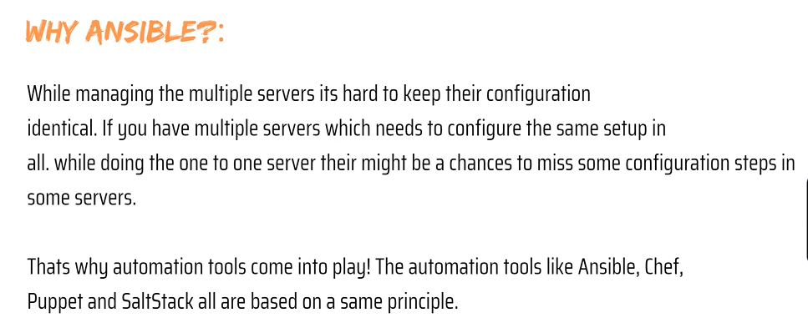

Ansible User Plain SSH. So, nothing needs to install on client machines. But other automation tools like Chef/Puppet needs to install agent on client machines when we need to perform a task.
Ansible is light weight, relative to use and speed of deployment compared to other tools. Ansible handle either via standard SSH commands, or the paramo module which provides a python interface to SSH2.

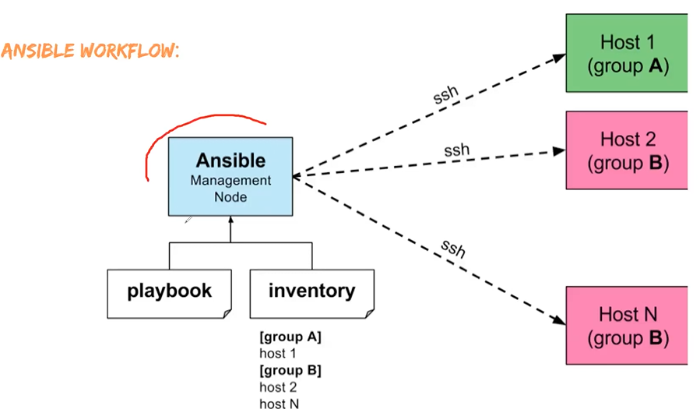

What is SSH?
SSH, also known as Secure Shell or Secure Socket Shell, is a network protocol that gives users, particularly system administrators, a secure way to access a computer over an unsecured network.
SSH -https://docs.aws.amazon.com/AWSEC2/latest/UserGuide/ec2-instance-connect-set-up.html

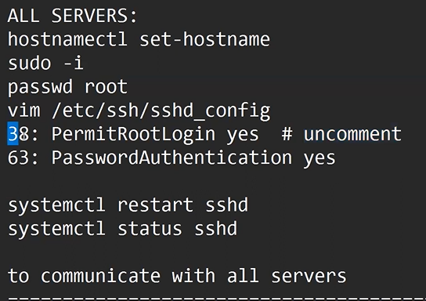
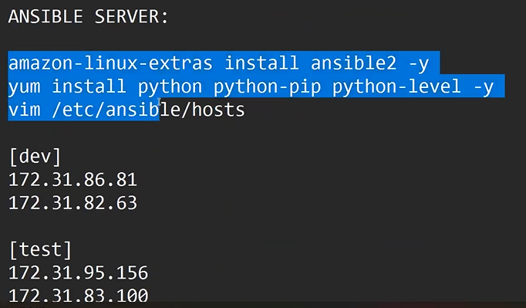
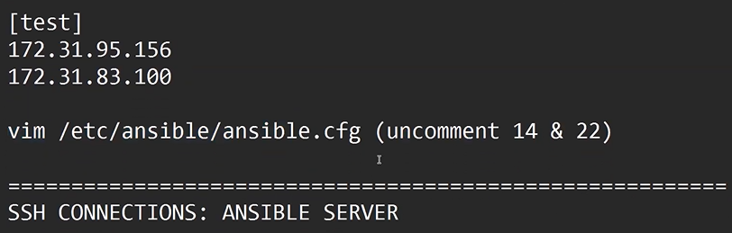
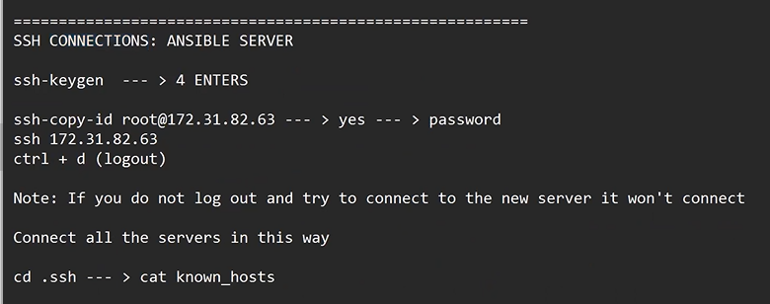
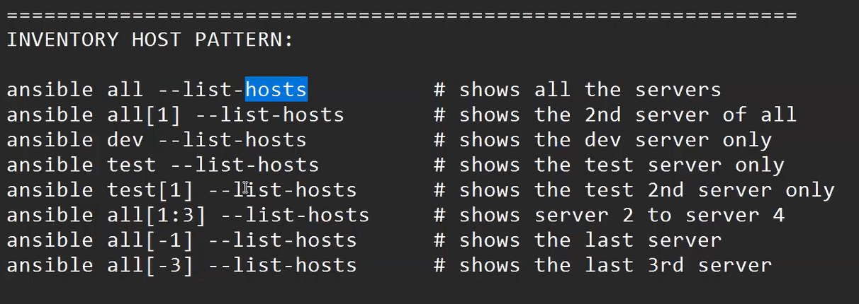
inventory host pattern ---> The Ansible inventory file defines the hosts and groups of hosts upon which commands, modules, and tasks in a playbook operate. The file can be in one of many formats depending on your Ansible environment and plugins.
Root user ---> Not used Sudo command.
Non-Root User ---> You must and should use Sudo command.
Ansible ADHOC commands are one-liner Linux shell commands and playbooks are like a shell script, a collective of many commands with logic.
Ansible ADHOC commands come handy when you want to perform a quick task.

Color: Identify terminal flow.
- Red: Failed.
- Yellow: Success
- Green: Already Done
- Blue: Skip
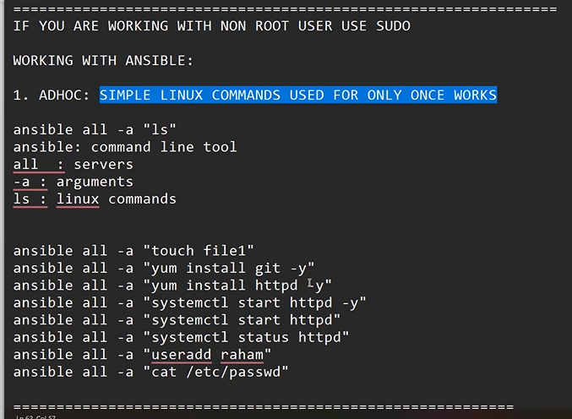

Videos – 44
A module is a reusable, standalone script that Ansible runs on your behalf, either locally or remotely. Modules interact with your local machine, an API, or a remote system to perform specific tasks like changing a database password or spinning up a cloud instance.
It is in the Key – Value format and it is Reusable.

Command different’ s
ADHOC Command: ansible all -a “yum install git -y”
Module Command:
ansible all -m yum -a “pkg=git state=present” -----> # (present mean = Install)
ansible all -m yum -a “pkg=git state=latest” ---------># (Latest = Update)
ansible all -m yum -a “pkg=git state=absent” -------> # (absent = Uninstall)
Set-Upping Httpd Service.
ansible all -m yum -a “pks=httpd state=present”
ansible all -m service -a “pks=httpd state=restarted” -----> # (Restarted – restart the service)
ansible all -m service -a “pks=httpd state=stopped” ----># (Stopped – stop the service)
ansible all -m user -a “name= RCB state=present”

Limitation Modules.
- We cannot Reuse the Modules.
- We cannot Execute multiple Modules.

Playbook.
How do Ansible Playbooks work?
Ansible Playbooks are lists of tasks that automatically execute for your specified inventory or groups of hosts. One or more Ansible tasks can be combined to make a play—an ordered grouping of tasks mapped to specific hosts—and tasks are executed in the order in which they are written. A playbook can include one or more play.
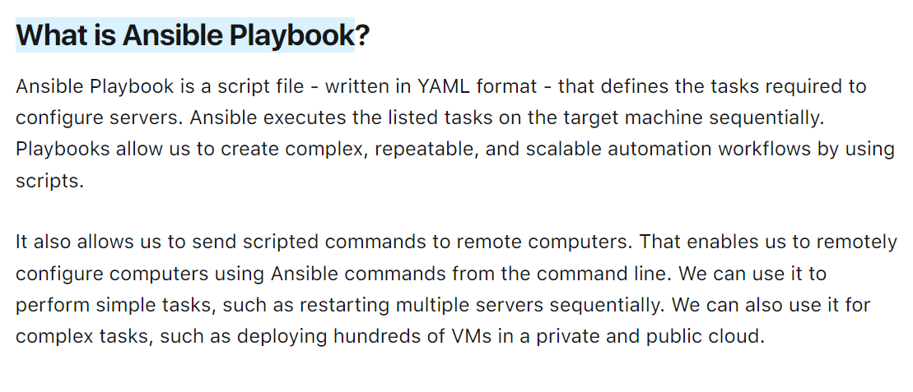
Playbook ----> It’s a collection of modules.
- Here we can multiple modules & we can reuse it.
- Playbook is written on yaml language.
- It works on key- value and its extension (Yaml /Yml)

Created Playbook ---> File name - raham.yml
Vim raham.yml

Module Command reference:
ansible all -m yum -a “pkg=git state=present” -----> # (present mean = Install)

playbook reference: single task
- hosts: all
tasks:
- name: Installing Git
yum: name or pkg = Git state=present
: wq!
Extrusion playbook command ---> ansible-playbook raham.yml
Multiple modules or multitask using in playbook set-upping HTTPd service.
Step:1----> vim raham.yml
Step2: Inside the raham.yml file we can write the task flow.
- hosts: all
tasks:
- name: Installing httpd
yum: name or pkg = httpd state=present
- name: restarting httpd
service: name = httpd state=restarted
- name: create a user
User: name= raja state=present
:wq!
Step3: ansible playbook raham.yml
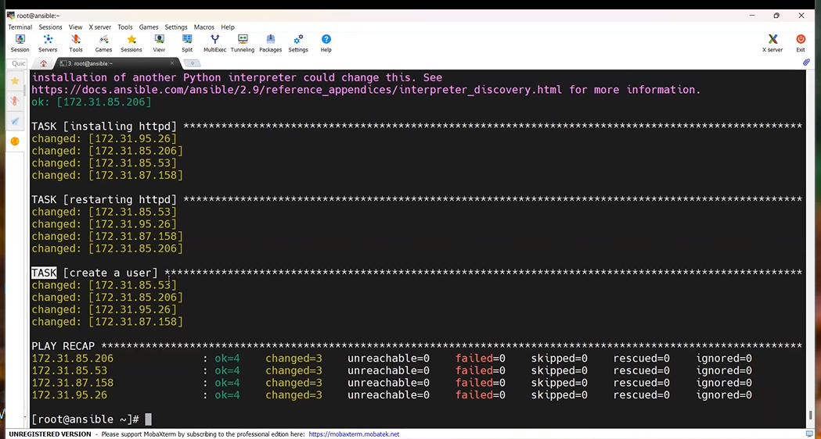
ansible all -a “yum remove git* https* java-1.8.0-openjdk* tree* -y”
Videos- 45
IF you have 100 service who we need to find through service run or not
- ansible -m ping all or ansible -m ping <piratical service group name>
Shell (Vs) Command (vs) Raw module
Step:1----> vim raham.yml
Step2: Inside the raham.yml file we can write the task flow.
- hosts: all
tasks:
- name: task-1
yum: name = git state=present

- name: task -2
Shell: yum install httpd -y

- name: task -3
Command: yum install tree -y

- name: task-4
raw: yum install java-1.8.0-openjdk -y
:wq!
Step3: ansible playbook raham.yml

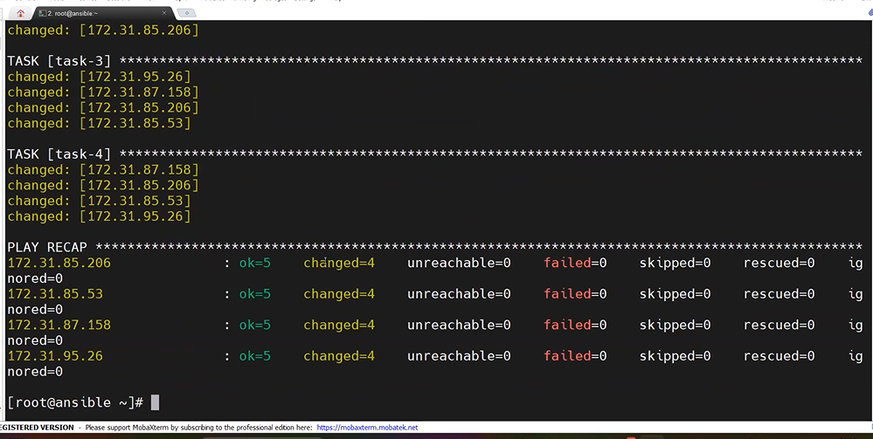
Uninstall Service
Step:1----> vim raham.yml
Step2: Inside the raham.yml file we can write the task flow.
- hosts: all
tasks:
- name: task-1
yum: name = git state=absent

- name: task -2
command: yum remove httpd* -y

- name: task -3
Command: yum remove tree* -y

- name: task-4
raw: yum remove java-1.8.0-openjdk* -y
:wq!
Step3: ansible playbook raham.yml
TAGS: - It will Execute/ skip the particular task among multiple tasks.
Ex: - Single Tags execution only install HttpD service
Step:1----> vim raham.yml
Step2: Inside the raham.yml file we can write the task flow.
- hosts: all
tasks:
- name: task-1
yum: name = git state=present
tags: A
- name: task -2
Shell: yum install httpd -y
tags: b
- name: task -3
Command: yum install tree -y
tags: C

- name: task-4
raw: yum install java-1.8.0-openjdk -y
tags: D
:wq!
Step3: ansible playbook raham.yml --tags B

Ex: - Multe Tags execution only install tree and java service
Step1 – above task flow step same
Step2 - Above task flow step same
Step3 - ansible playbook raham.yml --tags C D
Skip-Tags Ex: - If 5 tags or 5 service are there in that only 4 Service want to run application.
With help of Skip-Tags we can do that.
Step1 – above task flow step same
Step2 - Above task flow step same
Step3 - ansible playbook raham.yml – skip-tags ‘’C”
:wq!
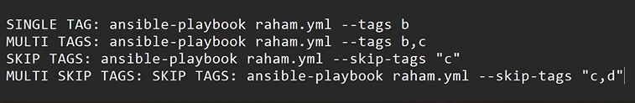
======================******************========================
Variables Which will vary, and it will store the value.
Dynamic vars: - The vars which can be passed outside of the playbook during execution or Runtime.
Step:1----> vim raham.yml
Step2: Inside the raham.yml file we can write the task flow.
- hosts: all
tasks:
- name: task-1
yum: name = {{a}} state=present
Step3: ansible playbook raham.yml –extra-vars ‘’a=docker”
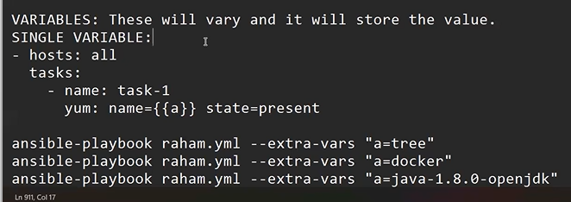
*******************
Multle
Step:1----> vim raham.yml
Step2: Inside the raham.yml file we can write the task flow.
- hosts: all
tasks:
- name: task-1
yum: name = {{a}} state=present
- name: task-2
Yum: name = {{b}} state=present
Step3: ansible playbook raham.yml --extra-vars ‘’a=tree b=docker”
**Static Variable: These variables are declared inside the playbook.
Step:1----> vim raham.yml

Step2: Inside the raham.yml file we can write the task flow.
- hosts: all
vars:
a: Git
b: Maven
tasks:
- name: task-1
yum: name = {{a}} state=present
- name: task-2
Yum: name = {{b}} state=present
(OR)
tasks:
- name: task-1
yum: name = {{a}} state=present
yum: name = {{b}} state=present

Step3: ansible playbook raham.yml

Stopping Gather facts
- hosts: all
gather_facts: false
vars:
a: git
b: maven
tasks:
-name: task-1
Yum: name= {{a}} state= present
Yum: name= {{b}} state=present
Step3: ansible playbook raham.yml

Videos- 46
1. Cluster: Group of nodes / Servers.
Homogenies Cluster: All service are same flavours.
Heterogenies Cluster: All service are different flavours.
Ex: Flavours – Red hat, Ubuntu ect…
There are 4 service are there in that 2 are red hat and 2 are Ubuntu mean.
It called Heterogenies.
If all services are red hat or Ubuntu through service called homogenies.
Conditions: When the heterogeneous cluster we will used these conditions.
Task -2 Ex: if you have one playbook and two different service (Redhat, Ubuntu) who will running the services.
To solve this problem we are using When connecting see the below task 1 represent if service Redhat can install or setup service and task-2 will be skip the setup flow .why because we are using redhat service right now.
Step1: Vim raham.yaml
Step2: Inside the file we can write task’s flow.
- hosts: all
Tasks:
- name: task-1
Command: yum install tree -y
When: ansible_os_family == “RedHat”
- name: task-2
command: apt install tree -y
When: ansible_os_family == “Debian”
:wq!
Step3: - ansible-playbook raham.yaml

Handlers: It will execute when called by other tasks.
One task is depending on another task.
Notify mean – First task executed then second task executed.

Ex:
- hosts: all
tasks:
- name: Install httpd
command: yum install httpd -y
notify: restart httpd
handlers:
- name: restart httpd
Command: systemctl restart httpd
: wq!

Loops: It will do Operation recursively or reduce length of the code
Ansible loop is used to repeat any task or a part of code multiple times in an Ansible-playbook. It includes the creation of multiple users using the user module, installing multiple packages using apt or yum module or changing permissions on several files or folders using the file module.

Ex: -
- hosts: all
tasks:
- name: task-1
yum: name={{item}} state=present
With_items:
- git
- maven
- docker
- tree
: wq!

Ex-2: Created User’s:
- hosts: all
tasks:
- name: task-1
user: name={{item}} state=present
With_items:
- RCB
- CSK
- RR
- SRH
: wq!

ROLES: -----> It will create a directory structure for our playbooks.
------> It will encapsulate the playbook.
------> It will be used for community as well.

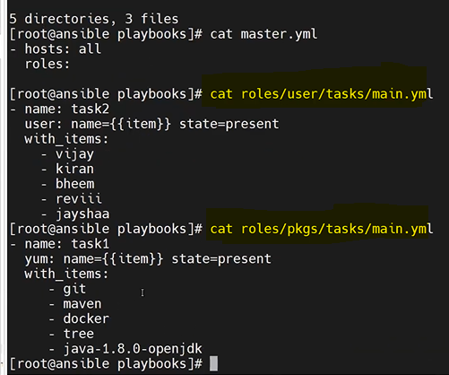

Ex: Two playbook are there – one playbook installs service and other one created user’s
Step1: mkdir playbook ------> Created one playbook dir
Step2: cd playbook/ ---> change the director or move the playbook dir.
Step3: Vim master. yaml ------> Created a folder or file master.
Step4: Inside the master. Yml file to write some tasks.
- hosts: all
roles:
:wq!

Step5: mkdir -p roles/pkgs/tasks -------------------> Other folder cratering name as roles and for ex we need to install any package that file name as – pkgs, -p director inside director can give -p. and other sub-director created name as – Tasks.

Step6: yum install tree -y
Step7: tree
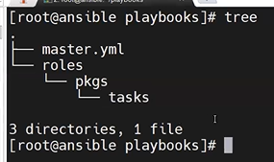

Step8: vim roles/pkgs/tasks/main.yml ---------------------> Again one more file creation name – main.yml.
Step9: Inside the main.yml file write task.
- hosts: all
tasks:
- name: task-1
yum: name={{item}} state=present
With_items:
- git
- maven
- docker
- java-1.8.0-openjdk
: wq!

Step10: tree
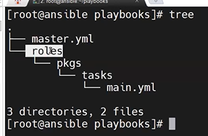
Step11: mkdir -p roles/user/tasks -----------------> To created user directory/ roles inside the roles.
Step12: tree
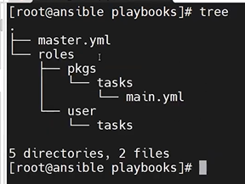

Step13: vim roles/user/tasks/main.yml
Step14: Inside the main.yml write the task.
- name: task-2
user: name={{item}} state=present
With_items:
- RCB
- CSK
- RR
- SRH
: wq!
Step15: tree
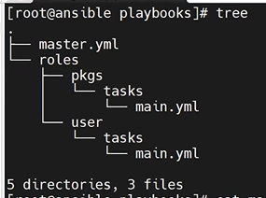
Step16: cat master.yml
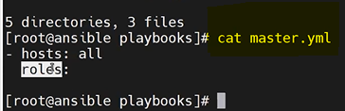
Step17: cat roles/user/tasks/main.yml
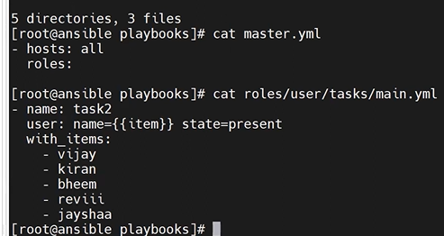
Step18: cat roles/pkgs/tasks/main.yml
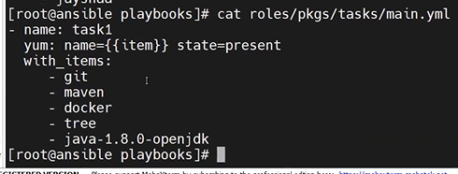
Step19: Vim master. yaml
Step20: inside the master file we wite task flow. ----------> only install the package in the service’s
-hosts: all
roles:
- pkgs
: wq!

Steps21: ansible-playbook master.yml

Galaxy: It will store the roles of multiple users in a central place.
Ansible-galaxy search java
ansible-galaxy install baztian
ansible-galaxy search –author baztian

Videos- 47
DEBUG: It is used to print the message. Or debug module is used to print the output to the terminal.
Ex: vim abc.yaml
- hosts: all
tasks:
-name: printing a msg
debug:
msg: “Hello world”
: wq!

ansible-playbook abc.yaml

@@@@@@@@@@@@@@@@@@@@@@@@@@@@@@@@

To install service, we are calling name list:

Redhat: ---------> yum/rpm

Ubuntu: ----------> apt/apt-get

Python: -----------> pip module

NumPy & Pandas ------------> Libs

Kartikeya soft:
Ansible: Day: - 37
Step1: Creating 2 EC2 instance name as (1. Ansible-Main and 2. Ansible_ Node1)
Step2: Connection through SSH key
$ ssh -i k8s.pem ec2-user@privite IP address
k8s.pem (we need to give you pem file name)
Step3: Moving to root user.
sudo su –
Step4: Installing ansible. (Portal web sitelink: -https://www.digitalocean.com/community/tutorials/how-to-install-and-configure-ansible-on-centos-7 )
yum update -y
sudo yum install epel-release
Copy the line To Use, Run command.
sudo amazon-linux-extras install epel
sudo yum install ansible

Step5: checking- ansible --version – 2.9.27

Hint: - Ansible is a tool written in Python, and it uses the declarative markup language YAML to describe the desired state of devices and configuration.

Step6: Creating inventory vim inventory
Step7: Inside the inventory-file write.
Giving nodes host ip address
[dev]
192.168.1.2
192.168.1.3
[Test]
10.1.0.1
10.2.0.1
[WEB]
IND-WEB-01
IND-WEB-01
:wq!

Step8: To call the Group of nodes - inventory command.
ansible -i inventory all --list-hosts
Step9: To creating any number of group inventory.
Step10: vim prod-inv
Step11: Inside the prod-inv file write the service IP address.
[PROD]
172.16.2.1
172.16.3.1
172.16.4.1
: wq!
Step12: Calling the inventory file.
ansible -i prod-inv all --list-hosts

Day: - 38 --> one node to another node connecting.

Step13: Creating 2 EC2 instance name as (1. Ansible-main and 2. Ansible-Node1)
FirstNode :Ansible-Main IP Address- 3.81.56.255
Flowing the previous class steps (Step: 3, 4, 5) – Already Ansible service are there mean we can skip these steps.

Step14: Connecting Second Node (Node name: Ansible-Node1, IP Address -54.161.131.80)

Note: We configure the First Node to second Node connecting.
Step15: Switch the ec2-user command.
exit (By Default it will switch main user)

Step16: Inside the main user (ec2-user) creating the one directory.
mkdir ksworking
Step17: And moving or change to Ksworking dir.
cd ksworking/
Step18: Again, creating directory inside the ksworking.
[ec2-user@ip address ksworking] $ mkdir ksdev
mkdir kstest
mkdir ksweb
mkdir ksapp
mkdir ksprod
Step19: list the file inside the ksworking.
ls -------------------------> O/P: ksdev kstest ksweb ksapp ksprod

Step20: To change directory ksdev.
cd ksdev/
Step21: Inside the ksdev we are creating inventory.
ec2-user@ip address ksdev] $ vim inv
Step22: Inside the inv file we add group node or IP Address. (Giving the second node private IP Address)
[Dev]
172.31.36.135
: wq!
Step23: To call inventory or check service set.
ansible -i inv Dev –list-hosts
O/P: - hosts (1):
172.31.36.135

Step24: To check the Ansible config file = /ect/ansible/ansible.cfg
ansible--version
Step25: To change ansible directory.
ec2-user@ip address ksdev] $ cd /ect/ansible/
Step26: To check the list file inside ansible file.

ec2-user@ip address ansible] $ ls ------------> O/P: ansible.cfg hosts roles

Note: what is your default inventory ------>Ans: - Hosts
Step26: To check the default inventory inside the ansible server Uncommented node.
sudo vim /ect/ansible/hosts
Inside the file uncomment node (192.168.100.1)
: wq!
cd
[ec2-user@ip address ~] $ ansible all –list-hosts
O/P: - hosts (1):
192.168.100.1
Step27: move or change direction where that the placing cfg file.
[ec2-user@ip address ~] $ cd ksworking/
[ec2-user@ip address ksworking] $ cd ksdev/
[ec2-user@ip address ksdev] $ ls ---------------------> O/p: inv

Step28: Know we are communicating the second node server(Ansible-node1).
give the pem file name.
vim k8s.pem
we are copy the pem file text and pasting inside the vim k8s.pem file.
: wq!
Step29: After generating key file – if case you want to be giving the permission your key pair command called:
chmod 600 k8s.pem
Note: Only main user can access or authenticate the file we are giving permission give command chmod 600 <file_name>

Adhoc command: - Single line command.

Step30: listing file inside the ksdiv folder.
[ec2-user@ip address ksdev] $ ls -------------> O/p: inv k8s.pem

Step31: To changes Inside the ksdev folder inventory and passing the module ti ping command.
ansible -i inv DEV –private-key=k8s.pem -u ec2-user -m ansible.builtin.ping

Step32: Using Adhoc command and creating directory.
ansible -i inv DEV –private-key=k8s.pem -u ec2-user -m ansible.builtin.file -b -a ‘’dest=/ec2-user/KS state=directory”

NOTE: -b command: Become user to giving permissions to file.

Step33: Open the second node (Ansible-Node1) and check the file creation KS dir file or not.
[ec2-user@ip address ~] $ cd /ec2-user/
[ec2-user@ip address ec2-user] $ ls ----------->O/P: KS
Step34: Back to First Node (Ansible) and created other one director.
Hint: We are in ansible main node.
ansible -i inv DEV –private-key=k8s.pem -u ec2-user -m ansible.builtin.file -b -a ‘’dest=/ec2-user/DevOps state=directory”

Step35: Check the second directory created in second node (Ansible-Node1).
Hint: we are in Second Node
[ec2-user@ip address ec2-user] $ ls ----------->O/P: KS DevOps

Step36: Again, creating one more service name: (Ansible-Node 2)

Step37: Inset the three node (Ansible-Node2) IP Address inside the inventory file.
Hint: we are in ansible main node
[ec2-user@ip address ksdev] $ vim inv
Inside the inv file updating the three node IP Address.
[DEV]
172.31.36.135
172.31.41.124
: wq!
Step38: The below command inside the two node (ansible-node1, node2) Devops directory folder will create.
ansible -i inv DEV –private-key=k8s.pem -u ec2-user -m ansible.builtin.file -b -a ‘’dest=/ec2-user/DevOps state=directory”

Step39: To check the devops dir display or not inside the three Node(ansible-node2)
Hint: know we are in three node.
[ec2-user@ip-172-31-41-124 ~] $ cd /ec2-user/
[ec2-user@ip address ec2-user] $ ls ----------->O/P: Devops

Step40: Again calling the directory command to created a KS dir folder.
Hint: we are in ansible main node
ansible -i inv DEV –private-key=k8s.pem -u ec2-user -m ansible.builtin.file -b -a ‘’dest=/ec2-user/KS state=directory”

Step41: To check the KS dir display or not inside the three Node(ansible-node2)
Hint: we are in three node
[ec2-user@ip-172-31-41-124 ~] $ cd /ec2-user/
[ec2-user@ip address ec2-user] $ ls ----------->O/P: Devops KS

Step42: If case you want to delete the dir using adhoc command.
ansible -i inv DEV –private-key=k8s.pem -u=ec2-user -m ansible.builtin.file -b -a ‘’dest=/ec2-user/KS state=absent”

Step43: To creating web service package install with help of adhoc command.
Hint: we are in ansible main node
ansible -i inv DEV –private-key=k8s.pem -u ec2-user -m ansible.builtin.file -b -m ansible.builtin.yum -a ‘’name=httpd state=present’’
Step44: check the Httpd server working in second and three nodes.
Hint: we are in three nodes. And check two nodes also.
[ec2-user@ip-172-31-41-124 ec2-user] $ systemctl status httpd

Step45: To starting the service using adhoc command.
Hint: we are in ansible main node
ansible -i inv DEV –private-key=k8s.pem -u=ec2-user -m ansible.builtin.file -b -m ansible.builtin.service -a ‘’name=httpd state=started’’

Step46: To check the service stated or not.
Hint: we are in three nodes. And check two nodes also.
[ec2-user@ip-172-31-41-124 ec2-user] $ systemctl status httpd

Step47: Copy all nodes IP address and check the httpd service are not working r not in browser.
Hite: Open chrome browser and past the two and three nodes IP address.

Step48: To stop the service using Adhoc command.
Hint: we are in ansible main node
ansible -i inv DEV –private-key=k8s.pem -u=ec2-user -m ansible.builtin.file -b -m ansible.builtin.service -a ‘’name=httpd state=stopped’’

Day: - 39 --> Adhoc command customization
Customization mean: mean’s here we have ansible.cfg file there we can unable the key and user file.

Step49: Inside the Ksprod directory folder adding production information.
Change directory ksprod.
[ec2-user@ip address ksworking] $ cd ksprod/
[ec2-user@ip address ksprod] $ ls ---------->O/p: Nofile are there

Step50: To create a vim inv file.
[ec2-user@ip address ksprod] $ vim inv
Inside the inv file giving the node’s information.
[PROD]
192.168.29.12
192.168.29.13
: wq!
Note: If any case above IP address does not flow give you’re instance IP address.
Step51: To calling or check inv file command.
[ec2-user@ip address ksprod] $ ansible -i inv PROD --list-hosts
O/P: hosts (2):
192.168.29.12
192.168.29.13
Step52: Inside the ksprod no private key know are r creating that.
Vim Ks.pem
Inside the ks.pem file copying the pem file text. (Hint: Where you are save the pem file in that open any notepad copy that txt and past inside the vim k8s.pem)
: wq!
[ec2-user@ip address ksprod] $ ls -l ---->
O/P: [-rw-rw-r—l ks ks 37 oct 11 21:12 inv
-rw-rw-r—l ks ks 37 oct 11 21:14 ks.pem]
Step54: To giving the permission of ks.pem file.
chmod 600 ks.pem

[ec2-user@ip address ksprod] $ ls -l ---->
O/P: [-rw-rw-r—l ks ks 37 oct 11 21:12 inv
-rw-------—l ks ks 37 oct 11 21:14 ks.pem]

Step55: To ping the module inside the Inv PROD file.
ansible -i inv PROD --private.key= ks.pem -u=ec2-user -m ping

Step56: customization the ansible.cfg file and copy in the cfg file in locally.

[ec2-user@ip address ksprod] $ cp /ect/ansible/ansible.cfg .

[ec2-user@ip address ksprod] $ ls ---->O/P: - ansible.cfg inv ks.pem
Step57: Open the ansible.cfg file to customize the file.
Vim ansible.cfg
Change the inventory file name as – inv
: wq!
Step58: Don’t pass inv file while ping Ahdoc command.
ansible PROD --private.key= ks.pem -u=ec2-user -m ping
Step59: Know private key and user customization inside the ansible.cfg file.
Vim ansible.cfg
search: - :/private_key_file
Change the private_key_file name as = Ks.pem
search: - :/remote_user
Change the remote user name as = ec2-user
Hint: (Remove the before text and giving your pem file name and user name)
: wq!
Step60 : Again calling Adhoc command and removing the private key name and user name.
ansible PROD -m ansible.builtin.ping
--------------------------
Ansible Play book: No of tasks.
ansible playbook syntax:
Playbook_file1.yaml
- name: stmt-1
hosts: PROD
tasks:
- name: task1
module 1
- name: task1
module 2
- name: stmt-2
hosts: DEV
tasks:
- name: task1
module 1
- name: task1
module 2
[what is Playbook --> No of Tasks.
It’s a collection of modules.
Here we can multiple modules & we can reuse it.
Playbook is written on yaml language.
It works on key- value and its extension (Yaml /Yml)]
Step61: Installing VS- Code in your local system.
Inside VSCode creating ansible folder.
Inside VSCode install ansible plunging
Step62: created one demo1.yaml file to writing playbook.
File name: demo1.yaml
---
- name : demo on playbook
hosts : PROD
tasks :
- name : play-book 1st task
ansible.builtin.ping :

Step63: copy playbook task in vim demo1 file
[ec2-user@ip address ksprod] $ vim demo1.yaml
copy text in demo1 file.
: wq!
Step64: Execution the playbook task or calling ping command.
ansible-playbook demo1.yaml

DAY -40: playbook
Step65: list file inside Ksprod folder.
ls ----------->O/P: ansible.cfg demo1.yaml inv ks.pem
Step66: Creating one directory name prod-play folder.
mkdir prod-play
Step67: moving or changing direction.
[ec2-user@ip address ksprod] $ cd prod-play/
Step68: copy playbook task in demo1 file and pasting in Vim pb1.yaml.
[ec2-user@ip address ksprod] $ vim pb1.yaml
past Inside the pb.1yaml
: wq!
Step69: To running the Pinging command back to Ksprod folder change dir command.
[ec2-user@ip address prod-play] $ cd ..
Step70: Execution the playbook task or calling ping command.
[ec2-user@ip address ksprod] $ ansible-playbook prod-play/pb1.yaml

Step71: In VS code creating another playbook file to write task’s.
VSFile name: pb2.yaml: hint: - debug command
---
- name : First play
hosts : PROD
tasks :
- name : play1 and task1
ansible.builtin.debug:
msg: “Welcome to kertikeyasoft Devops”
- name : play1 and task2
ansible.builtin.debug:
msg: “Welcome to kertikeyasoft AWS”
- name : Second play
hosts : PROD
tasks :
- name: play2 and taks1
Ansible.builtin.debug:
msg: “Welcome to kertikeyasoft Kubernetes”
- name: play2 and taks2
Ansible.builtin.debug:
msg: “Welcome to kertikeyasoft AZureDevops”
Step72: copy playbook task in VScode and pasting.
[ec2-user@ip address ksprod] $ vim prod-play/pb2.yaml
copy text in demo1 file.
: wq!
Step73: : Execution the playbook task.
ansible- playbook prod-play/pb2.yaml
Step74: : In VS code creating another playbook file to writing variable task’s.
VSFile name: pb3.yaml: hint: - Variable command
- name : pb on vars
hosts : PROD
vars :
NAME : Kertikeyasoft
tasks :
- name : print the vars
ansible.builtin.debug:
msg: “Welcome to {{NAME}}”
Step75: copy pb3.yaml playbook task in VScode and pasting.
[ec2-user@ip address ksprod] $ vim prod-play/pb3.yaml
copy text and past inside the pb3.yaml file.
: wq!
Step76: Execution the playbook task.
ansible- playbook prod-play/pb3.yaml

Step77: Vim external_vars task’s.
external_vars.yaml: hint: - Variable in included files command
Name : ks
TRAINING : DEVOPS
BATCH : 87
:wq!

Step78: Know external vars text calling in your playbook. In VS code creating another playbook file to writing variable task’s.
VSFile name: pb4.yaml: hint: - external_vars calling tasks
- name : pb on vars_file
hosts : PROD
vars_files :
- external_vars.yaml
tasks :
- name: print vars from vars_files
ansible.builting.debug:
msg : “Name is {{Name}}”

- name: print vars from vars_files
ansible.builting.debug:
msg : “Training is {{TRAINING}}”

- name: print vars from vars_files
ansible.builting.debug:
msg : “Batch is {{BATCH}}”
Step79: copy pb4.yaml playbook task in VScode and pasting in pb4.yaml.
[ec2-user@ip address ksprod] $ vim prod-play/pb4.yaml
copy text and past inside the pb4.yaml file.
: wq!
Step80:: Execution the playbook task.
ansible- playbook prod-play/pb4.yaml
Step81: vars_prompt tasks. In VS code creating another playbook file to writing variable task’s.
VScode – pb5.yaml: hint: - vars_prompt command
- name : playbook on vars_prompt
hosts : PROD
vars_prompt :
- name : “USERNAME”
Prompt : “Please enter the service account name”
Private : false --------------------------------->hint : we are able to see username display .
- name : “PASSWD”
Prompt : “Please enter the service account password”
tasks :
- name : print the service account user name
ansible.builtin.debug :
msg : “{{USERNAME}}”

- name : print the service account user password
ansible.builtin.debug :
msg : “{{PASSWD}}”
Step82: copy pb5.yaml playbook task in VScode and pasting in Vim pb5.yaml.
[ec2-user@ip address ksprod] $ vim prod-play/pb5.yaml
copy text and past inside the pb5.yaml file.
: wq!
Step83: Execution the playbook task.
ansible- playbook prod-play/pb5.yaml
Please enter the service account Username: Kartikeya
Please enter the service account User passwd:

Step84: In Inventory level calling variable file
vim inv
[PROD]
192.168.29.12
192.168.29.13

[PROD: Vars]
BATCH = 87
COURSE = DEVOPS
Step85: In VS code creating another playbook file to writing In Inventory level calling variable file.
VSFile name: pb6.yaml: Here we didn’t calling variable it placed in inventory level.
- name : pb on Inventory level calling variable file
hosts : PROD
tasks :
- name: print vars from vars_files
ansible.builting.debug:
msg : “Batch is {{BATCH }}”

- name: print vars from vars_files
ansible.builting.debug:
msg : “Course is {{COURSE}}”
Step86: copy pb6.yaml playbook task in VScode and pasting in pb6.yaml.
[ec2-user@ip address ksprod] $ vim prod-play/pb6.yaml
copy text and past inside the pb6.yaml file.
: wq!
Step87: Execution the playbook task.
ansible- playbook prod-play/pb6.yaml

Day-41:
Step88: [ec2-user@ip address ~] $ ls -------------> O/P: KSworking
Step89: change directory
[ec2-user@ip address ~] $ cd ksworking/
Step90: List the file present inside the ksworking dir folder.
[ec2-user@ip address ksworking] $ ls --------->O/P: ksdev ksprod kstest
Step91: changing the dir for ksworking to ksprod.
[ec2-user@ip address ksworking] $ cd ksprod/
Step92: List the file present inside the ksprod dir folder.

[ec2-user@ip address ksprod] $ ls ---------->O/P: ansible.cfg demo1.yaml inv ks.pem prod-play
Step93: Installing httpd server in Linux. In VS code creating another playbook file to writing task’s install web services .
VScode – pb7.yaml: hint: - Installing httpd server.
- name : PB on web layer
hosts : PROD
become: yes -------> [hint: become command add because you need to be root to perform this task]
tasks :
- name : installing web server
ansible.bulitin.yum :
name : httpd
state : latest / absent (Hint: in you system httpd server already there mean you can uninstall server : absent states.)
- name : starting web server
ansible.builtin.service :
name : httpd
state : started
Step94: copy pb7.yaml playbook task in VScode and pasting in vim web.yaml.
[ec2-user@ip address ksprod] $ vim prod-play/web.yaml
copy text and past inside the web.yaml file.
: wq!
Step95: Execution the playbook task.
ansible- playbook prod-play/web.yaml

3-Tier Architecture: Web, App, DB
Web Layer:
Installing httpd package.
Service Start.
Download modkjk connector.
Extracting modjk
gcc, httpd -devel
Compile.
. /configure --with-apxs=/bin/apxs
Mod_jk.so – Module [ we are using connecting web to app through mod jk]

Step96: Download the mod_jk
https://tomcat.apache.org/download-connectors.cgi
Copying: https://dlcdn.apache.org/tomcat/tomcat-connectors/jk/tomcat-connectors-1.2.49-src.tar.gz

Step98: Installing Mod_jk server in Linux. In VS code creating another playbook file to writing task’s install mod-jk services.
VScode – pb8.yaml: hint: - Installing mod_jk connector.
- name : PB on web layer
hosts : PROD
become: yes
tasks :
- name : installing web server
ansible.bulitin.yum :
name : httpd
state : latest

- name : starting web server
ansible.builtin.service :
name : httpd
state : started

- name : Creating mod_jk working directory
ansible.builtin.file:
path : /KSwork
mode : ‘0766’
state : directory

- name : Downloading mod_jk connector
ansible.builtin.get_url :
url : https://dlcdn.apache.org/tomcat/tomcat-connectors/jk/tomcat-connectors-1.2.49-src.tar.gz
dent: /KSwork
Step94: copy pb8.yaml playbook task in VScode and pasting in vim web.yaml.
[ec2-user@ip address ksprod] $ vim prod-play/web.yaml
copy text and past inside the web.yaml file.
: wq!
Step95: Execution the playbook task.
ansible-playbook prod-play/web.yaml

Step97: To check the mod_jk server install or not in your ansible node’s (node1 and node2)
Hint: we are in two nodes checking the mod_jk server install are not. After that check again three Node also.
[ec2-user@ip-172-31-41-124 ~] $ cd /
[ec2-user@ip-172-31-41-124 / ] $ ls -------> [bin, boot, dev, ect, home, ksapp, KSwork, lib, lib64, media, mnt, opt, proc, root, run, sbin, sys ect..]
[ec2-user@ip-172-31-41-124 /] $ cd KSWork/
[ec2-user@ip-172-31-41-124 KSWork] $ ls -----> [tomcat-connectors-1.2.49-src.tar.gz]

Step98: Installing Mod_jk server in Linux. In VS code creating another playbook file to writing task’s install mod-jk services.
VScode – pb8.yaml: hint: - Extracting Mod_jk.
- name : PB on web layer
hosts : PROD
become: yes
tasks :
- name : installing web server
ansible.bulitin.yum :
name : httpd
state : latest

- name : starting web server
ansible.builtin.service :
name : httpd
state : started

- name : Creating mod_jk working directory
ansible.builtin.file:
path : /KSwork
mode : ‘0766’
state : directory

- name : Downloading mod_jk connector
ansible.builtin.get_url :
url : https://dlcdn.apache.org/tomcat/tomcat-connectors/jk/tomcat-connectors-1.2.49-src.tar.gz
dent: /KSwork

- name : Extracting mod_jk
ansible.builtin.unarchive :
src : /KSWork/ tomcat-connectors-1.2.49-src.tar.gz
dent: /KSwork
remote_src : Yes

Step94: copy pb8.yaml playbook task in VScode and pasting in vim web.yaml.
[ec2-user@ip address ksprod] $ vim prod-play/web.yaml
copy text and past inside the web.yaml file.
: wq!
Step95: Execution the playbook task.
ansible-playbook prod-play/web.yaml
Step97: To check the mod_jk server Extracting or not in your ansible node’s (node1 and node2)
Hint: we are in two nodes checking the mod_jk server Extracting are not. After that check again three Node also.
Before command [ec2-user@ip-172-31-41-124 KSWork] $ ls -----> [tomcat-connectors-1.2.49-src.tar.gz]
[ec2-user@ip-172-31-41-124 KSWork] $ ls -l
-----> [drwxr-xr-x 9 root bin tomcat-connectors-1.2.49-src
-rw-r—r--1 1 root root tomcat-connectors-1.2.49-src.tar.gz

[ec2-user@ip-172-31-41-124 KSWork] $ cd tomcat-connectors-1.2.49-src
[ec2-user@ip-172-31-41-124 tomcat-connectors-1.2.49-src ] # ls --------> O/P: [ conf, HOWTO-RELEASE.txt, LICENSE, NOTICE, support, xdocs, docs, jkstatus, native, README.txt, tools]

[/configure --with-apxs=/bin/apxs ]
[ec2-user@ip-172-31-41-124 tomcat-connectors-1.2.49-src ] # cd native/

[ec2-user@ip-172-31-41-124 native] # ls- l
--->O/P: [aclocal.m4, apache-2.0, buildconf.sh, BUILDING.txt, common, configure, configure.ac, docs, iis, Markefile.am, Makefile.in, README.txt, scripts, TODO.txt]
Install apxs,C -compiler and some more.
Step98: Dependences Pack installation server in Linux. In VS code creating another playbook file to writing task’s install mod-jk services.

VScode – pb8.yaml: hint: - Dependences pack Installation – apxs ect...
- name : PB on web layer
hosts : PROD
become: yes
tasks :
- name : installing web server
ansible.bulitin.yum :
name : {{item}}
state : latest
loop:
- httpd
- gcc
- httpd-devel

- name : starting web server
ansible.builtin.service :
name : httpd
state : started

- name : Creating mod_jk working directory
ansible.builtin.file:
path : /KSwork
mode : ‘0766’
state : directory

- name : Downloading mod_jk connector
ansible.builtin.get_url :
url : https://dlcdn.apache.org/tomcat/tomcat-connectors/jk/tomcat-connectors-1.2.49-src.tar.gz
dent: /KSwork

- name : Extracting mod_jk
ansible.builtin.unarchive :
src : /KSWork/ tomcat-connectors-1.2.49-src.tar.gz
dent: /KSwork
remote_src : Yes

Step94: copy pb8.yaml playbook task in VScode and pasting in vim web.yaml.
[ec2-user@ip address ksprod] $ vim prod-play/web.yaml
copy text and past inside the web.yaml file.
: wq!
Step95: Execution the playbook task.
ansible-playbook prod-play/web.yaml

Day- 42:
Tips:
cd mod_jk/native
. /configure –with-apxs=/bin/apxs
make, make install.
Step98: Directory enter server in Linux. In VS code creating another playbook file to writing task’s install mod-jk services.

VScode – pb8.yaml: hint: - Directory enter – using shell_module...
- name : PB on web layer
hosts : PROD
become: yes
tasks :
- name : installing web server
ansible.bulitin.yum :
name : {{item}}
state : latest
loop:
- httpd
- gcc
- httpd-devel
- make

- name : starting web server
ansible.builtin.service :
name : httpd
state : started

- name : Creating mod_jk working directory
ansible.builtin.file:
path : /KSwork
mode : ‘0766’
state : directory

- name : Downloading mod_jk connector
ansible.builtin.get_url :
url : https://dlcdn.apache.org/tomcat/tomcat-connectors/jk/tomcat-connectors-1.2.49-src.tar.gz
dent: /KSwork

- name : Extracting mod_jk
ansible.builtin.unarchive :
src : /KSWork/ tomcat-connectors-1.2.49-src.tar.gz
dent: /KSwork
remote_src : Yes

- name : compile mod_jk package
shell : . /configure –with-apxs=/bin/apxs
args :
step:99 following chdir : /opt/tomcat-connectors-1.2.49- src/native

- name : execute make cmd
shell : make
args :
chdir : /opt/tomcat-connectors-1.2.49- src/native

- name : execute make install cmd
shell : make install
args :
chdir : /opt/tomcat-connectors-1.2.49- src/native

[mod_jk url find]
Step99: [ec2-user@ip-172-31-41-124 tomcat-connectors-1.2.49-src ] # cd native/
[ec2-user@ip-172-31-41-124 native] # ls
--->O/P: [aclocal.m4, apache-2.0, buildconf.sh, BUILDING.txt, common, configure, configure.ac, docs, iis, Markefile.am, Makefile.in, README.txt, scripts, TODO.txt]
[ec2-user@ip-172-31-41-124 native] # pwd
---->O/P: /opt/tomcat-connectors-1.2.49- src/native

Step94: copy pb8.yaml playbook task in VScode and pasting in vim web.yaml.
[ec2-user@ip address ksprod] $ vim prod-play/web.yaml
copy text and past inside the web.yaml file.
: wq!
Step95: Execution the playbook task.
ansible-playbook prod-play/web.yaml

Step98: Directory enter server in Linux. In VS code creating another playbook file to writing task’s install mod-jk services.

VScode – pb8.yaml: hint: - Directory enter – using shell_module...
- name : PB on web layer
hosts : PROD
become: yes
tasks :
- name : installing web server
ansible.bulitin.yum :
name : {{item}}
state : latest
loop:
- httpd
- gcc
- httpd-devel
- make

- name : starting web server
ansible.builtin.service :
name : httpd
state : started

- name : Creating mod_jk working directory
ansible.builtin.file:
path : /KSwork
mode : ‘0766’
state : directory

- name : Downloading mod_jk connector
ansible.builtin.get_url :
url : https://dlcdn.apache.org/tomcat/tomcat-connectors/jk/tomcat-connectors-1.2.49-src.tar.gz
dent: /KSwork

- name : Extracting mod_jk
ansible.builtin.unarchive :
src : /KSWork/ tomcat-connectors-1.2.49-src.tar.gz
dent: /KSwork
remote_src : Yes

- name : compile mod_jk package
shell : “{item}”
args :
chdir : /opt/tomcat-connectors-1.2.49- src/native
loop :
- . /configure –with-apxs=/bin/apxs
- make
- make install
Step94: copy pb8.yaml playbook task in VScode and pasting in vim web.yaml.
[ec2-user@ip address ksprod] $ vim prod-play/web.yaml
copy text and past inside the web.yaml file.
: wq!
Step95: Execution the playbook task.
ansible-playbook prod-play/web.yaml

Step96: Automate install two servicer and uninstall few with help of Loop- Iterating Over a list of hashes.
Step98: Two pack’s install and Two pack’s uninstall server in Linux. In VS code creating another playbook file to writing task’s

VScode – pb8.yaml: hint: - Loop- Iterating Over a list of hashes
- name : PB on web layer
hosts : PROD
become: yes
tasks :
- name : installing web server
ansible.bulitin.yum :
name : “{{item.name}}”
state : “{{item.state}}”
loop:
- {name : ‘httpd’ , state : ‘latest’ }
- {name : ‘httpd-devel’ , state : ‘latest’ }
- {name : ‘gcc’ , state : ‘latest’ }
- {name : ‘make’ , state : ‘latest’ }

- name : starting web server
ansible.builtin.service :
name : httpd
state : started

- name : Creating mod_jk working directory
ansible.builtin.file:
path : /KSwork
mode : ‘0766’
state : directory

- name : Downloading mod_jk connector
ansible.builtin.get_url :
url : https://dlcdn.apache.org/tomcat/tomcat-connectors/jk/tomcat-connectors-1.2.49-src.tar.gz
dent: /KSwork

- name : Extracting mod_jk
ansible.builtin.unarchive :
src : /KSWork/ tomcat-connectors-1.2.49-src.tar.gz
dent: /KSwork
remote_src : Yes

- name : compile mod_jk package
shell : “{item}”
args :
chdir : /opt/tomcat-connectors-1.2.49- src/native
loop :
- . /configure –with-apxs=/bin/apxs
- make
- make install
Step94: copy pb8.yaml playbook task in VScode and pasting in vim web.yaml.
[ec2-user@ip address ksprod] $ vim prod-play/web.yaml
copy text and past inside the web.yaml file.
: wq!
Step95: Execution the playbook task.
ansible-playbook prod-play/web.yaml

Lineinfile - Ansible lineinfile module is used to insert a line, modify, remove, and replace a line or multiple lines in the host's configuration files..
Ex: prod-play/pb9.yaml
---
- name : PB on Line in file
hosts : PROD
become : Yes
tasks :
- name : Ensure SELinux is set to enforcing mode
ansible.builting.lineinfile :
path : /ect/selinux/config
regexp : ‘^SELINUX='
line : SELINUX=disabled

blockinfile module – Insert/update/remove a text block surrounded by marker lines.
Block of content update

Day – 43:
Ex: blockinfile.
---
- name : Demo on block in file
hosts : PROD
become : yes
tasks :
- name : Insert/Update “Match user” configuration block in /ect/ss
ansible.builtin.blockinfile:
path : /ect/ssh/sshd_config
block :
Match User ansible-agent
PasswordAuthentication yes

Step94: copy pb10.yaml playbook task in VScode and pasting in vim blockinfile.yaml.
[ec2-user@ip address ksprod] $ vim prod-play/blockinfile.yaml
copy text and past inside the blockinfile.yaml file.
: wq!
Step95: Execution the playbook task.
ansible-playbook prod-play/ blockinfile.yaml

Checking ansible Node1 and Node 2
[ec2-user@ip address ~] vim /ect/ssh/sshd_config
Seach: - :/Pass – passed that below text update.
ansible-agent PasswordAuthentication no

Step95:
vim modjk.conf --- File

LoadModule jk_module modules/mod_jk.so
JkWorkersFile conf.d/workers.properties
JkLogFile logs/mod_jk.log
JkLogLevel info
JkLogStampFormat "[%a %b %d %H:%M:%S %Y]"
JkOptions +ForwardKeySize +ForwardURICompat -ForwardDirectories
JkRequestLogFormat "%w %V %T"
JkMount /LoginApp tomcatA
JkMount /LoginApp/* tomcatA

vim workers.properties

worker.tomcatA.type=ajp13
worker.tomcatA.host=10.128.0.5
worker.tomcatA.port=8009

Step95:Checking ansible Node1 and Node 2
[ec2-user@ip address ~] #cd /opt/
[ec2-user@ip address opt] # ls ----->O/P: tomcat-connectors-1.2.49-src
[ec2-user@ip address opt] # cd tomcat-connectors-1.2.49-src/

[ec2-user@ip address tomcat-connectors-1.2.49-src/] # ls
----->O/P: [conf, HOWTo-RELEASE.txt, LICENSE, NOTICE, support, xdocs
Docs jkstatus native README.txt tools]
[ec2-user@ip address tomcat-connectors-1.2.49-src/] #
----> cd /ect/httpd/conf.d

[ec2-user@ip address conf.d] # ls ----->O/P: [autoindex.conf, README userdir.conf, welcome.conf]

[ec2-user@ip address conf.d] # pwd --->O/P: /ect/httpd/conf.d

Step95: ansible main node task
[ec2-user@ip address ksprod] $ ls ------> O/P: ansible.cfg demo1.yaml inv ks.pem prod-play
[ec2-user@ip address ksprod] $ cd prod-play/
[ec2-user@ip address prod-play] $ ls --->O/P: [blockinfile.yaml, lineinfile.yaml, stack.yaml]
[ec2-user@ip address prod-play] $ cd ..
[ec2-user@ip address ksprod] $

Step98: Two pack’s install and Two pack’s uninstall server in Linux. In VS code creating another playbook file to writing task’s

VScode – pb11.yaml: hint: - SDDM configuration file in showing Node’s
- name : PB on web layer
hosts : PROD
become: yes
tasks :
- name : installing web server
ansible.bulitin.yum :
name : “{{item.name}}”
state : “{{item.state}}”
loop:
- {name : ‘httpd’ , state : ‘latest’ }
- {name : ‘httpd-devel’ , state : ‘latest’ }
- {name : ‘gcc’ , state : ‘latest’ }
- {name : ‘make’ , state : ‘latest’ }

- name : starting web server
ansible.builtin.service :
name : httpd
state : started

- name : Creating mod_jk working directory
ansible.builtin.file:
path : /KSwork
mode : ‘0766’
state : directory

- name : Downloading mod_jk connector
ansible.builtin.get_url :
url : https://dlcdn.apache.org/tomcat/tomcat-connectors/jk/tomcat-connectors-1.2.49-src.tar.gz
dent: /KSwork

- name : Extracting mod_jk
ansible.builtin.unarchive :
src : /KSWork/ tomcat-connectors-1.2.49-src.tar.gz
dent: /KSwork
remote_src : Yes

- name : compile mod_jk package
shell : “{item}”
args :
chdir : /opt/tomcat-connectors-1.2.49- src/native
loop :
- . /configure –with-apxs=/bin/apxs
- make
- make install
- name: create SDDM configuration
copy:
dest : /ect/httpd/conf.d/
group : root
mode : 0644
owner : root
src : modjk.conf
remoteuser :yes

Step94: copy pb11.yaml playbook task in VScode and pasting in vim SDDM configuration.yaml.
[ec2-user@ip address ksprod] $ vim prod-play/ SDDM configuration.yaml
copy text and past inside the SDDM configuration.yaml file.
: wq!
Step95: Execution the playbook task.
ansible-playbook prod-play/ SDDM configuration.yaml

If case you are getting any error [ec2-user@ip address ksprod] $ mv modjk.conf prod-play /
Again running abovestep

Day-43; Stopping Videos – 40:45
Step95
Step95
Step95

